SUGGESTION 1
The prompt / description should be shorter…
Users will not read so much

SUGGESTION 2
Stripe Size
Size definition Micro 0.1 cm to 1 cm 0.2 mm to 1 mm
& Stripe Size Small 0.5 cm to 2 cm 0.2 mm to 2 mm
Meduim 2 cm to 5 cm 0.2 mm to 4 mm
Large 5 cm to 25 cm 0.5 mm to 10 mm

SUGGESTION 3

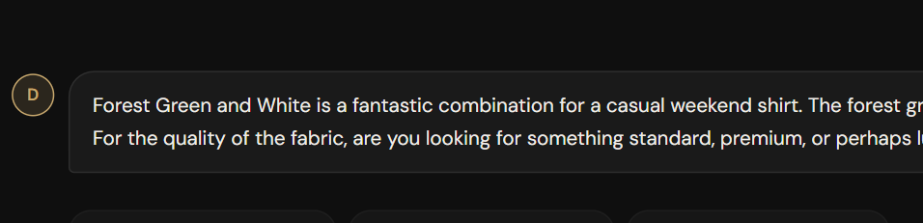

We are limiting only 2 colors in all our AI results

Normally we should ask / Give option
- HOW many color design is needed. 4, 5… 8… 12
- which one should be Base color
- For Forest green - AI should get
  - 2 or 3 Family colors - light green, Dark green( since Forest Green is medium color)
  - 1 contrast color - Gold / Red

If user says 10-12 colors then, AI should suggest colors as under

- Family color - 4-6
- Harmony color - 2-3
- Contrast color 1-2

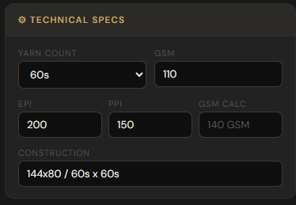
SUGGESTION 4
Remove
- EPI
- PPI
- GSM CALC

